LED Monitor control circuit (Dell U2412B / U2415)

The present circuit is a PCB design based on the original concept published by Georg Keller (FMI Basel) and implemented by Martyn Stopps (NIMR, London) to optimize footprint and production. This work is only the implementation of the circuit in to a PCB for easy manufacturing and replicating. The circuit provides the synchronization between each frame on the microscope acquisition and the flickering frequency of the screen back-illumination. The TTL signal to the LED of the Toshiba photocoupler TLP 2200 is generated in the two-photon acquisition software (ScanImage) from a modified line clock synchronized to the scanner DAQ board. This signal is transmitted to each of the four LED panels of the Dell U2415 display generating the desired current through the LED drivers BCR 421U E6327. The photocoupler also isolates the 5V control circuit from the 48V power circuit. The output current can be manually adjusted using an external 10Ω trimmer located with a 12Ω resistor (Rext), both in parallel with the Rint of the LED driver.
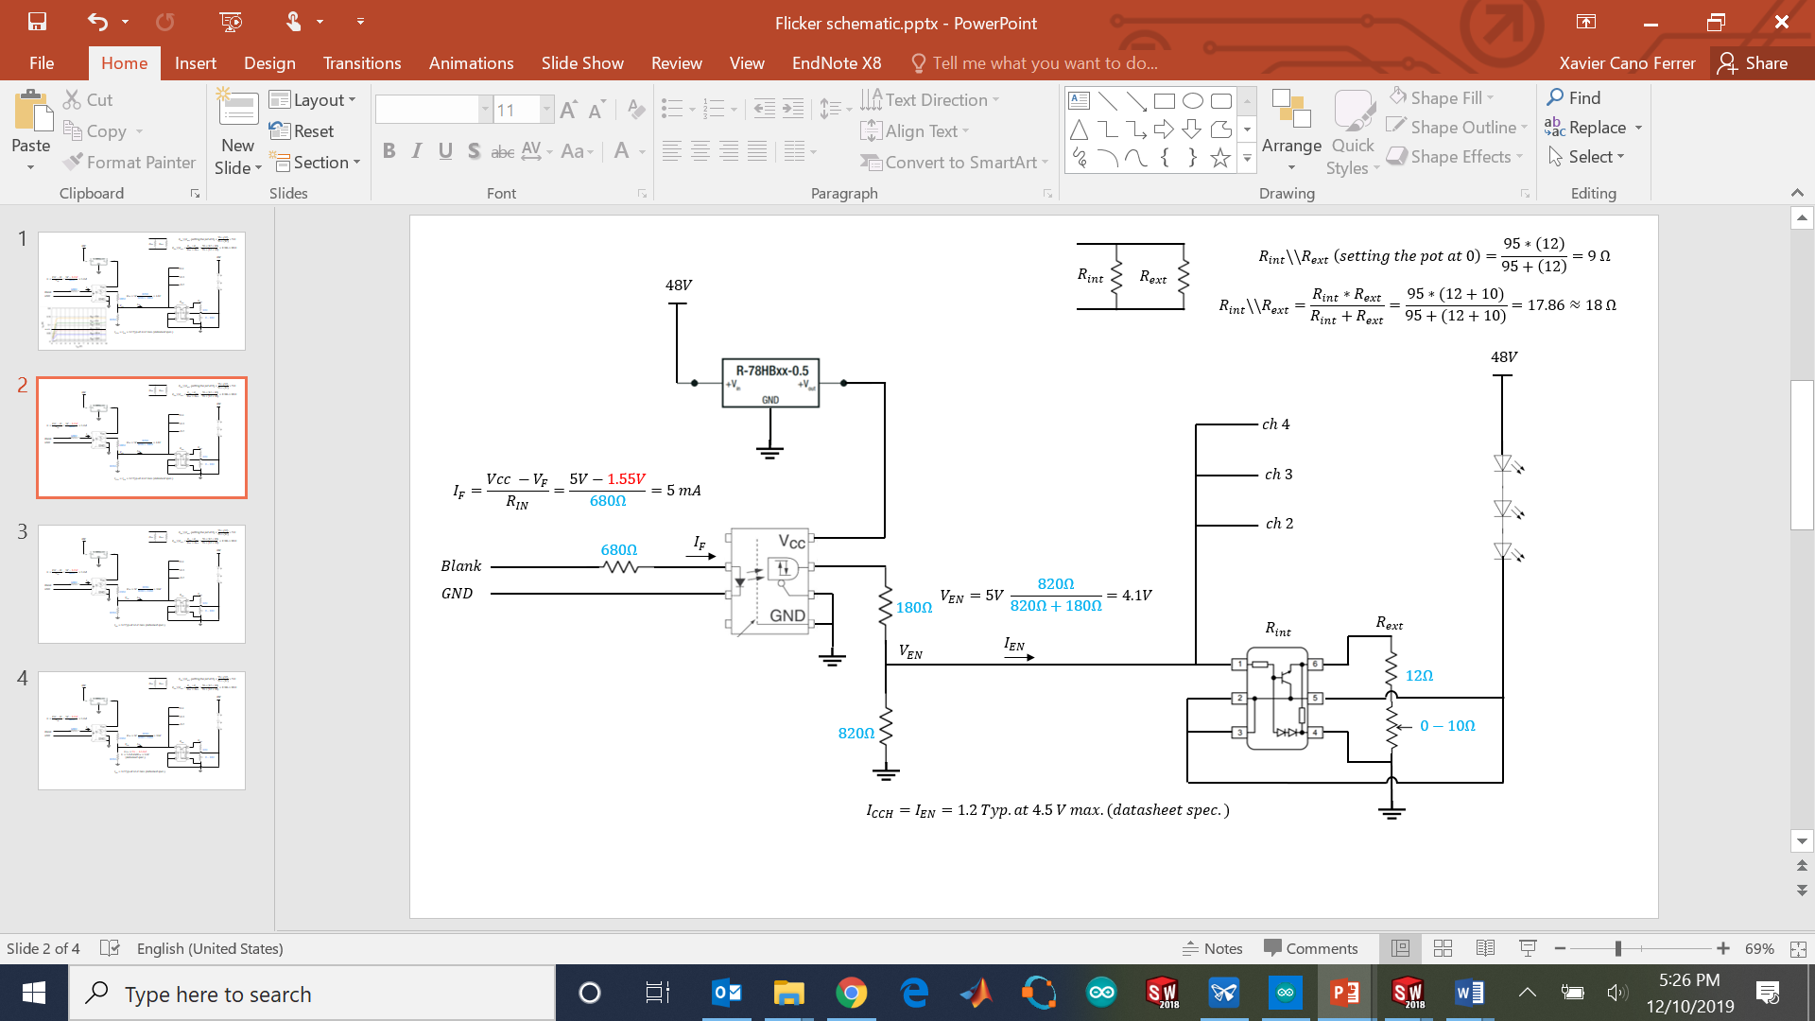
Figure 1: Circuit schematic.

Table 1 shows the relationships between the footprint name on the PCB drawing top layer and the component that must be inserted there.

Table 1: Placement of the components on the board.

Component | Value
R1 | 680R
R2 | 180R
R3 | 820R
R4 | 12R
R5 | 12R
R6 | 12R
R7 | 12R
JP3-JP7 | TLP2200
JP11 | R-78HB5.0-0.5L
JP35-JP24-JP46-JP57 | 10R trimmer
JP26-JP15-JP37-JP48 | LED Driver (BCR 421U E6327)
JP25-JP36-JP47-JP58 | Circular connector
JP2 | BNC connection
JP59 | Jack connector
JP61 | Circular connector

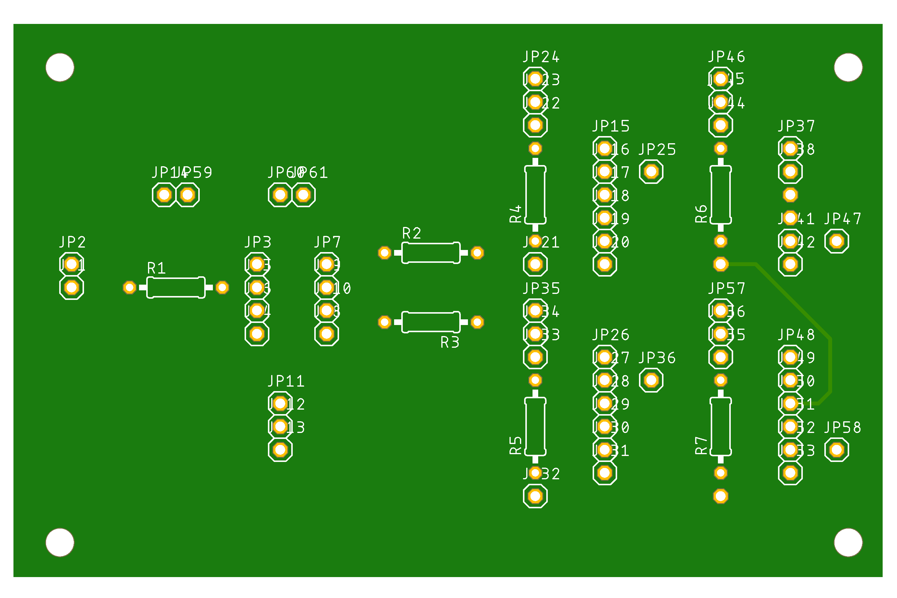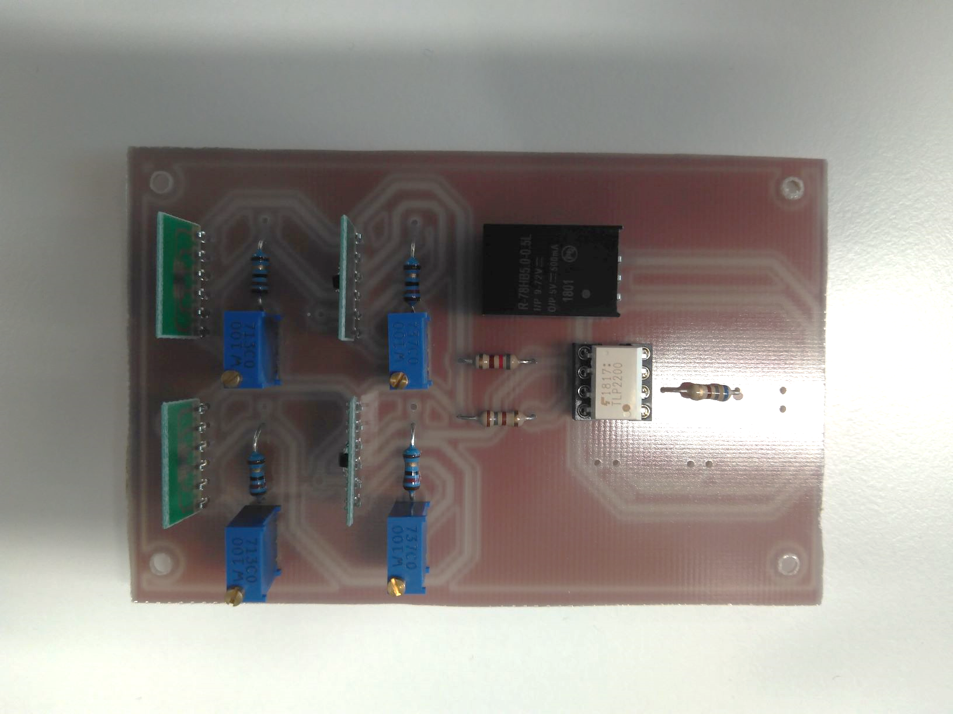
Figure 2: Top layer of the PCB circuit and main components soldered.

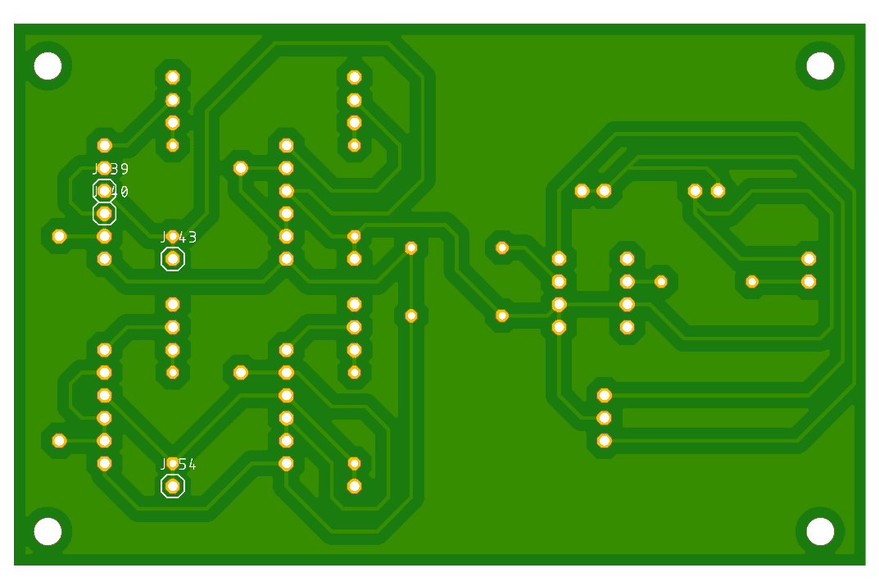
Figure 3: Bottom layer of the PCB circuit.

The track drawn on the top layer (Figure 2 and 4) can be created by soldering a cable between the two pads, this is useful if you have a CNC router able to do only single layer circuits.

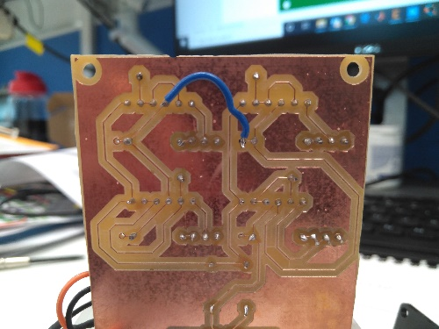
Figure 4: Wire soldered to create the path drawn on the top layer.

Table 2: Bill of materials
Component | Units | Reference
PCB CAM documents | 1 | CAM LED Driver Circuit
Case | 1 | 3D printed part
Spacer | 4 | 3D printed part
Case cover | 1 | 3D printed part
M3 threaded insert | 4 | RS components (278-534 )
PCB single layer | 1 | RS components (219-2123)
Power supply - 48V, 48W PSU | 1 | Farnell 1550930
LED Driver (BCR 421U E6327) | 4 | Farnell 1791068
SMD IC adaptor connector (33206) | 4 | Farnell 1654365
10R trimmer (3296W-1-100LF) | 4 | Farnell 9353151
DC converter 5V, 500mA (R-78HB5.0-0.5L) | 1 | Farnell 2440305
Photocoupler TLP2200 | 1 | Farnell 1225845
Resistor 12R 1/4W | 4 | -
Resistor 680R 1/4W | 1 | -
Resistor 180R 1/4W | 1 | -
Resistor 820R 1/4W | 1 | -
RF Coaxial BNC | 1 | Farnell 1205963
Circular connector UTS6JC12E10S | 1 | Farnell 1795863
Circular connector UTS012E10P | 1 | Farnell 1795893
Power input Jack | 1 | -
M3 screws | 8 | -

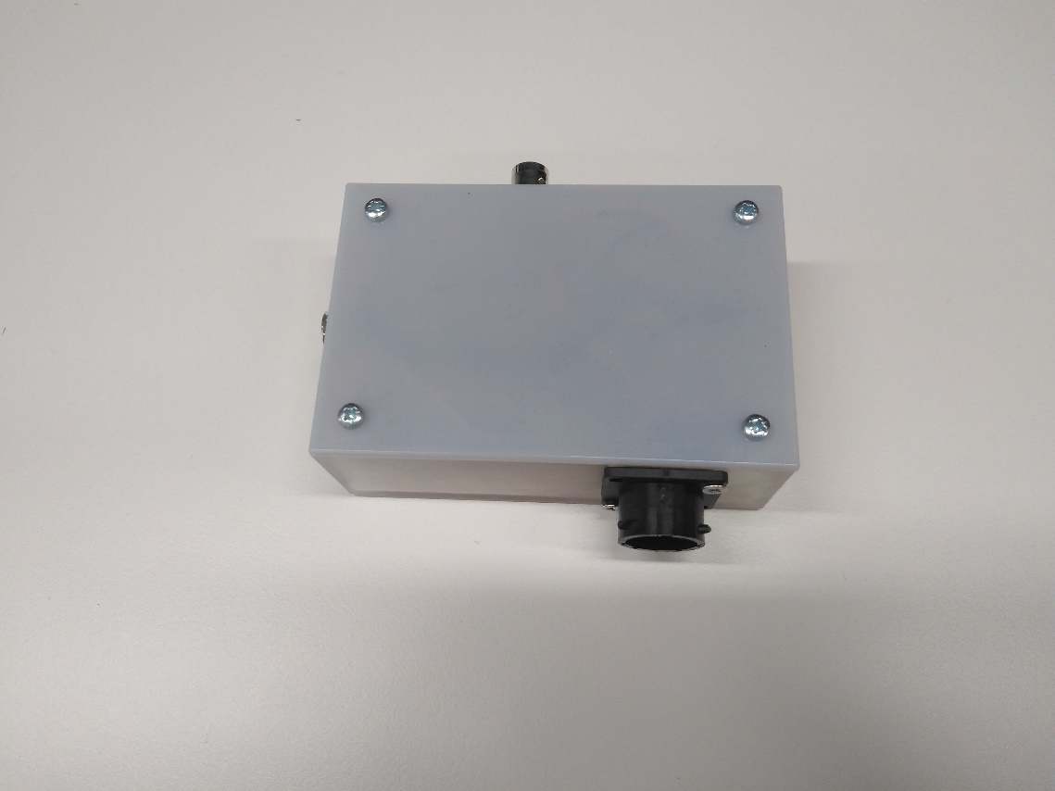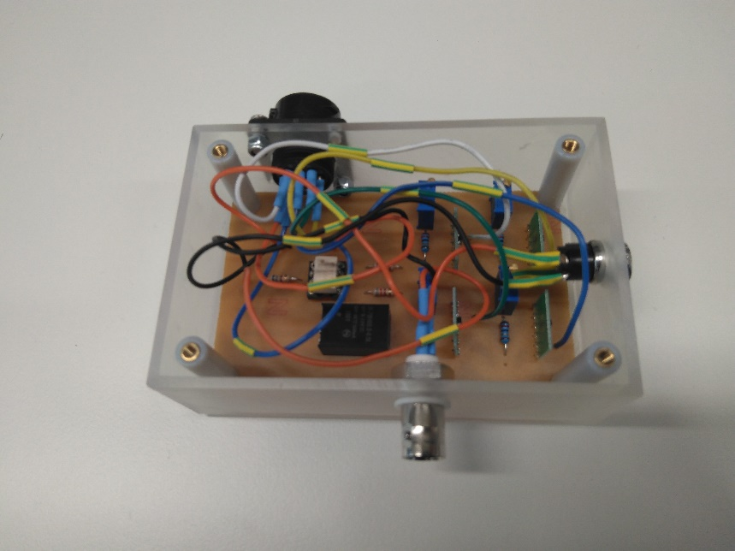
Figure 5: Final version of the board inside the box.

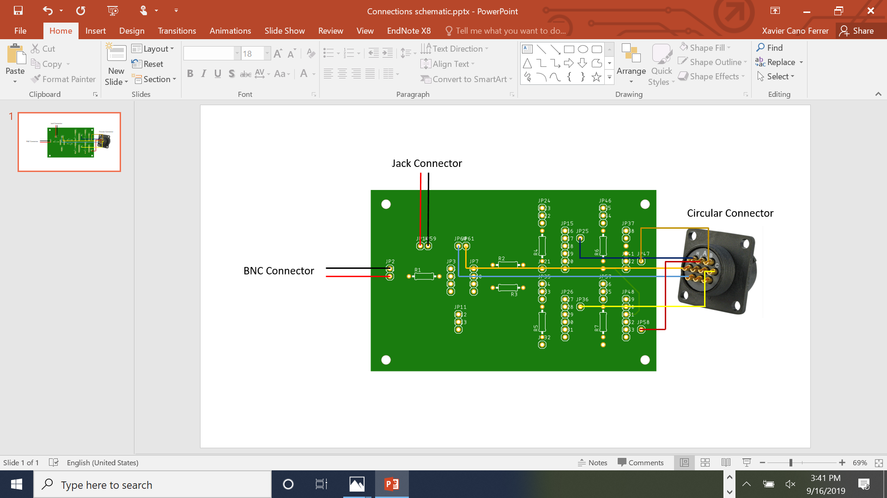

Figure 6: Connections from the PCB with the different connectors.

The output current generated with each driver is constant with different voltages and changes with Rext (Figure 7).
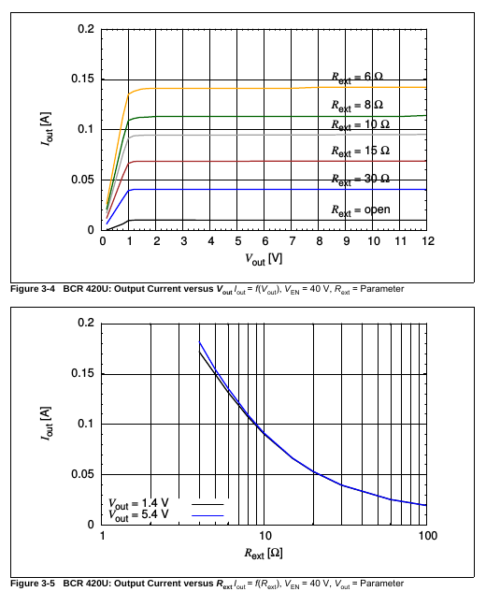
Figure 7: Output current with different resistance.

Once the board is manufactured, the back cover of the monitor must be opened with a screwdriver (Figure 8).
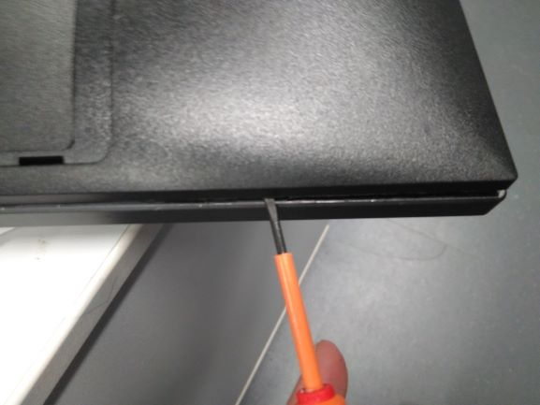
Figure 8: Back cover opening.
The back cover must be screwed with 4 M3 nylon screws and one 18 mm hole in the center for the connector. The cables have to be soldered to the connector.

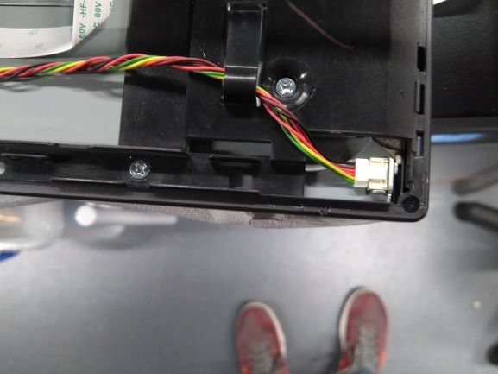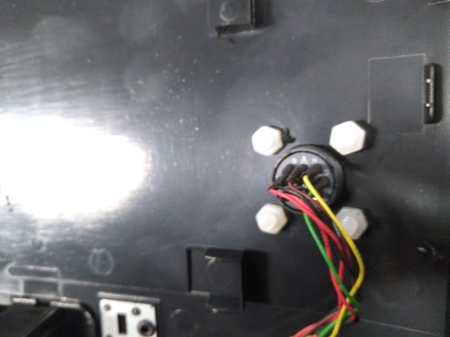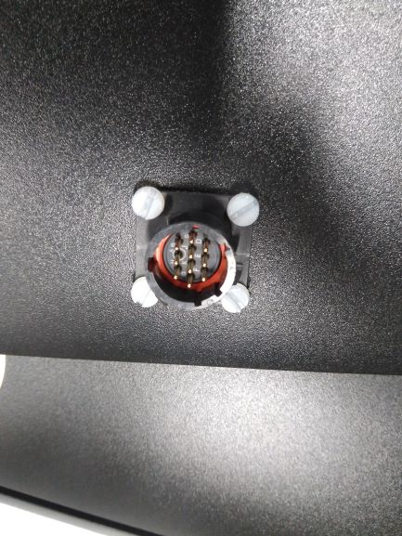
Figure 9: Cable soldering and connector placement.

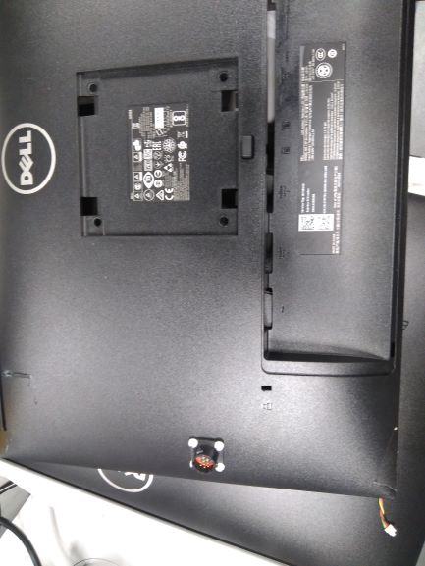
Figure 10: Back cover connector situation.

Table 3: Recommended connection between the cables on the 10 pin connector by order:
Wire | Connector pin
Green | G
Yellow | H
Red 1 | C
Red 2 | D
Brown | A
Black | B

Extra schematic used for the Eagle software:
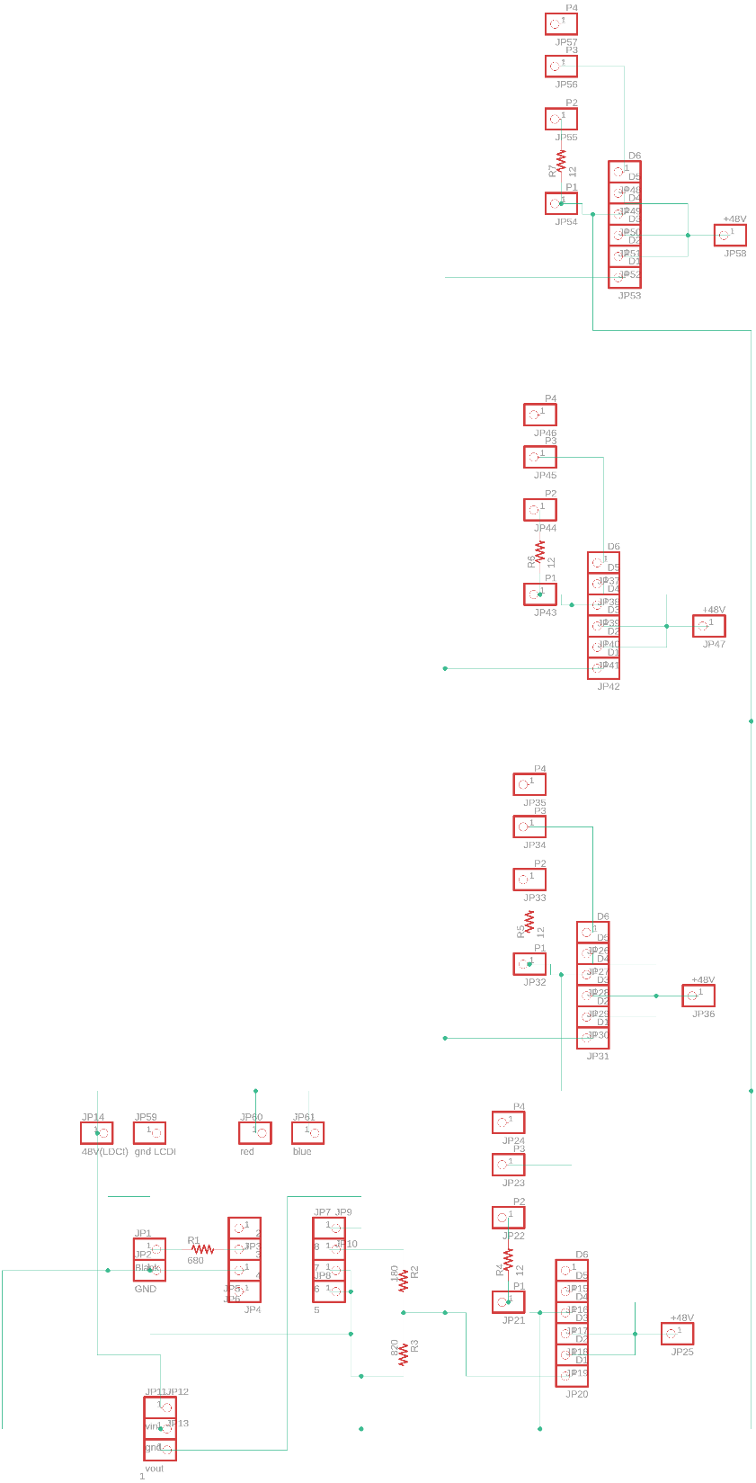
Figure 11: Eagle schematic.

Calibration procedure

In order to get the same brightness on the four panels first of all, the currents on each cable have to be measured (Table 4).

Table 4: U2415 measured currents

Wire | Current
Green | 72.7 mA
Yellow | 73.1 mA
Red 1 | 14.79 mA
Red 2 | 12.4 mA
Brown | 72.7 mA
Black | 72.7 mA

Then once the circuit is plugged (Table 5), we have to adjust the currents by adjusting the trimmer of each channel while the current is measured on an open cable where each cable can be plugged and unplugged from a screw connector (Figure 12). It is recommended to use four testers (one for each cable) to avoid loose time changing the tester in each measurement.
Table 5: Circuit test connections

Connector | Source
BNC | 5V DC (Signal generator)
JAC | AC/DC power converter 48V
Circular cable (10 pins) | On the monitor

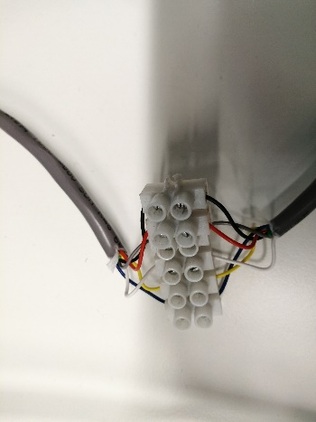
Figure 12: Test cable.
What we found on the calibration process was unexpected, the value of the supply current of the 3rd panel (Figure 13) was much higher than the other three channels being 160 mA with the maximum Rext value.
1 | 2 | 3 | 4
Figure 13: Test cable.
And the other three channels the expected value (47 mA). The other unexpected behavior was, the interdependency between this higher current value and the other three, which are otherwise independents. That happened with the five circuits we have produced.
Checking the ground connection of the monitors we also saw that this channel is not connected on the same GND, and it will be probably connected to some other active circuit that is making another function and therefore demanding this additional current.
After that we have tried to adjust the current measuring the brightness of each of the LED panels using a Thorlabs® photodetector PDA100A2 with an adjustable gain (40 dB). We tried to adjust the Voltage emitted for the photodetector on the same level for the four panels. The voltage was measured with the oscilloscope.
Because we don’t know how much current is passing through the panel number 3 we have chosen the option of putting all the trimmers at the minimum value and measure it with the photodetector. The maximum horizontal variation of the voltage registered from the photodetector was 12.5% approximately I the four circuits. The value registered with a vertical displacement of the photodetector (inside the same LED array) is also 12.5%.

